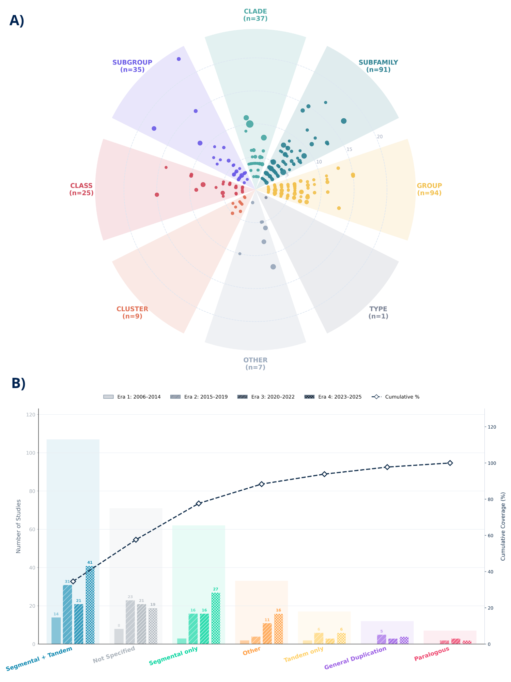
Figure 10. Phylogenetic structure archetypes and duplication signatures. (A) Radial astrolabe plot categorizing the phylogenetic trends. Dots represent individual studies, and radial distance represents the number of phylogenetic partitions. Dot size is proportional to the total number of genes identified per study. (B) Bar graph indicating the development of duplication signatures over the study eras. Different patterns of bars represent the different timelines. The dotted line represents the cumulative coverage (%) of studies for each type of duplication.

